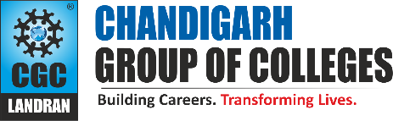
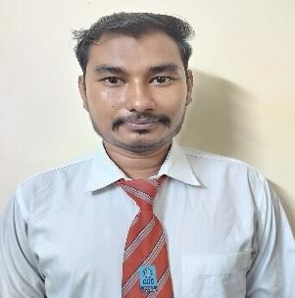

Sachin Kumar

Manpur Gaya, Distt. Gaya ji, Bihar - 823003
+91 7340808294
Sachin620924kumar@gmail.com LinkedIn:- sachin-kumar-a097222ba GitHub:- Sachin-kumar94 (Sachin Kumar)

PROFESSIONAL SUMMARY

Motivated Information Technology undergraduate with a strong foundation in HTML, CSS, and JavaScript, and practical experience in MERN stack web development. Passionate about building responsive web applications and continuously improving technical skills through real-world projects.

TECHNICAL COMPETENCIES

OS:- Windows, Linux, Mac OS Languages:- C++ | java
Frontend:- HTML | CSS | JavaScript | React.js
Databases:- MySQL | MongoDB

INTERPERSONAL SKILLS

Team Leadership | Management & Coordination | Decision Making Skills | Mentoring| Positive attitude | Adaptability

INTERESTS & HOBBIES

Hobbies:- Photography & Photo Editing | Cooking | Traveling |Watching movies Interests:- Listening to Music | playing Video Games | Sketching and drawing in free time

LANGUAGES KNOWN

English | Hindi

PERSONAL DETAILS

Mother’s Name:- Bobby Devi Father’s Name:- Om Prakash D.O.B:- 27-04-2006

EDUCATION
Bachelor of Technology in Information Technology | Chandigarh Engineering College, Landran
Session: 2023 – 2027 | CGPA: 7.5
Intermediate (BSEB) | M.S.Y College, Gaya Bihar Session: 2021-2023 | Percentage: 67.6%
Matriculation (CBSE)| Hansraj Public School, Bodhgaya, Bihar
Session: 2020-2021 | Percentage: 58%
TRAINING & PROJECTS

Real-Time Bus Tracking System
Technology: React.js, Node.js, Express.js, MongoDB, GPS, Google Maps API
Team Size: Group of 4 people
Description: Built a real-time bus tracking system to display live bus locations using GPS data. Developed backend APIs for location updates and integrated Google Maps for real-time visualization.

College Management System
Technology: React.js, Node.js, Express.js, MongoDB
Team Size: Individual
Description: Developed a full-stack College Management System to manage student records, faculty details, courses, attendance, and results. Implemented role-based access for admin, faculty, and students with secure authentication.

MERN Stack Training : EdiGlobe Pvt Ltd. | (June – July 2025) Technology: React.js, Node.js, MongoDB
Description: Completed 4-week MERN stack training. Built so many minor projects.

ACADEMIC ACHIEVEMENTS
- Participated in Smart India Hackathon (SIH), contributing to innovative problem-solving on real-world challenges.[2025].
- Actively participate in college-level tech events and workshops.

CERTIFICATIONS
- Infosys Springboard - Basics of Python & java Certification
- Participation Certificate – Trivia Technical Quiz, Zest-O Fiesta 2024, CEC Landran.
- AWS Academy Graduate - AWS Academy Cloud Operations
- Course Completion Certificate - MongoDB Database

EXTRA CURRICULAR & CO-CURRICULAR ACHIEVEMENTS
- Participated in many Quiz Competitions at college level
- Participated in many Non-technical event at college level

